1. Create directory/ sub-diretory

Ans: mkdir test_ag

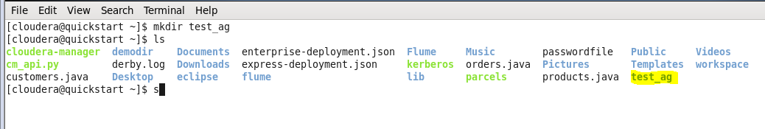

2. create a file inside the directory

Ans: touch file_ag

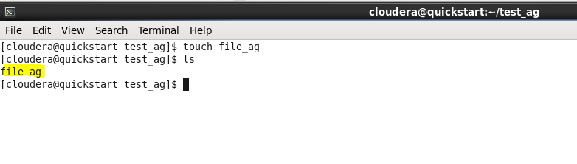

3. copy/move/delete command.

Ans: cp file_ag /home/cloudera/test_ag_1

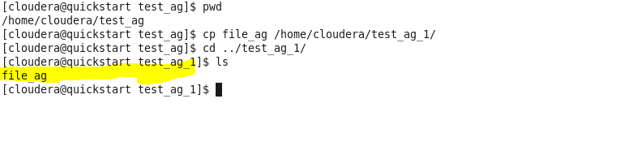

mv file_ag /home/cloudera/test_ag_1

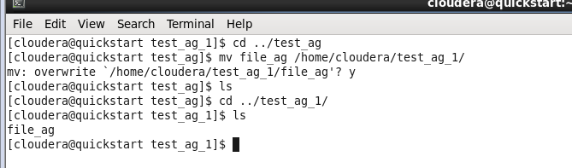

rm file_ag

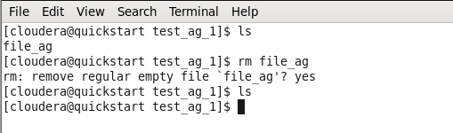

4. create user

Ans: sudo useradd -m ankur

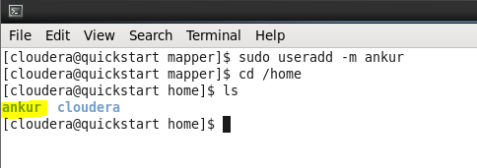

5. Add user to group

Ans: sudo chown ankur:cloudera ankur

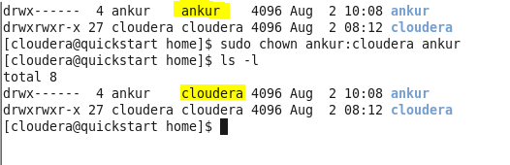

6. Set password

Ans: sudo passwd ankur

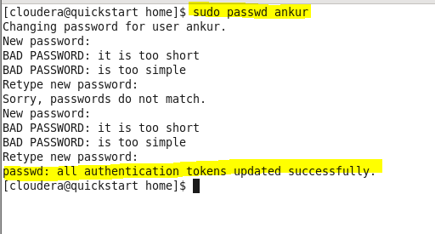

7. Create file and change ownership

Ans: touch testfile.txt

sudo chown root testfile.txt

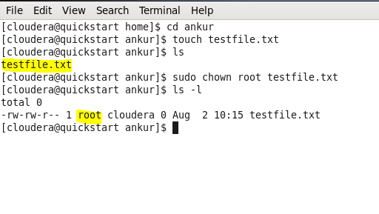

8. Change mode

Ans: chmod 777 testfile.txt

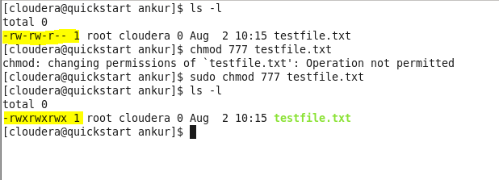

9. Setup password less communication between two user/vm

ssh-keygen

cat /home/cloudera/.ssh/id_rsa.pub > /home/cloudera/.ssh/authorized_keys

chmod go-w $HOME $HOME/.ssh

chmod 600 $HOME/.ssh/authorized_keys

chown `whoami` $HOME/.ssh/authorized_keys

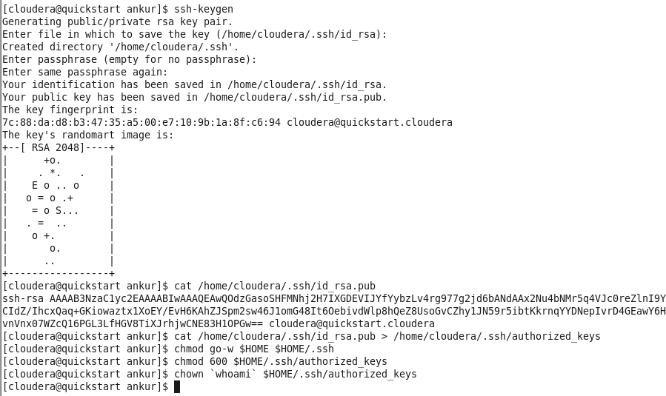

10. Create a file with some content and play with gedit/vi editor

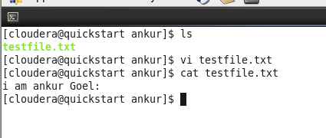

11. Provide full read/write/execution access for user, group and provide only read access for others.

Ans: sudo chmod 774 testfile.txt

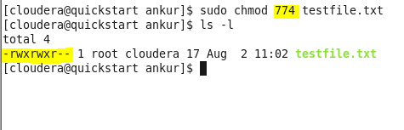

12. How to get currently logged in users?

Ans: whoami

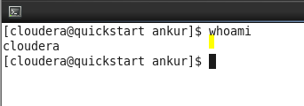

13. Compress /tar and un-compress /untar files

Ans: tar -czvf test.tar.gz /home/ankur/testfile.txt

tar -xzvf test.tar.gz

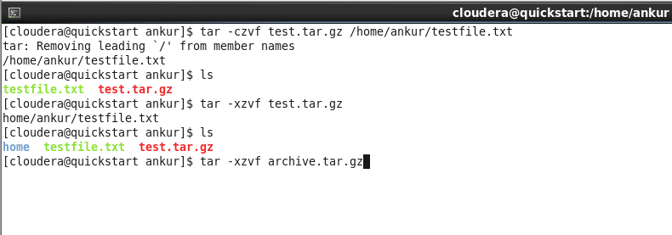

14. Work on few examples using grep and find commands for searching patterns.

Ans: grep -ir "ankur"

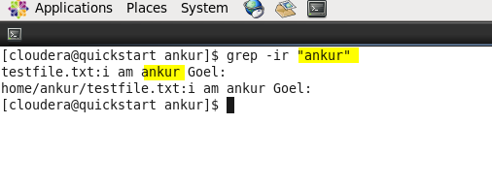

15. Using linux command, find the IP address of your current system?

Ans: ifconfig -a

